FINAL PROJECT REPORT
Leveraging Graph Neural Networks to Uncover
Illicit Financial Networks

Dataset: Elliptic Bitcoin Transaction Network
Models: GCN | GraphSAGE | GAT | XGBoost (Baseline)
Deadline: 19th March | Submitted by: Parth dhamija(240733)

1. Executive Summary
This project applies Graph Neural Networks (GNNs) to the Elliptic Bitcoin Dataset to detect illicit cryptocurrency transactions — a task representing the broader challenge of Anti-Money Laundering (AML) and financial fraud detection.
Financial crime is increasingly network-driven. Fraudsters operate in coordinated rings using techniques like smurfing (breaking large sums into small undetectable transactions) and peeling chains (rapid fund movement through intermediary wallets). Detecting these patterns requires analysing relational structure, not just individual transaction attributes.
Traditional approaches — rule-based engines and tabular ML models like XGBoost — treat transactions as independent events and cannot capture multi-hop network context. GNNs, by contrast, learn node representations by aggregating information from neighbours, enabling them to detect the sub-graph topologies characteristic of fraud rings.
We benchmark three GNN architectures (GCN, GraphSAGE, GAT) against an XGBoost baseline, across two feature configurations (all features vs. local-only), yielding seven evaluation points in total.

2. Dataset Details

2.1 Overview
The Elliptic Dataset is a public, labelled graph of Bitcoin transactions created in collaboration with Elliptic, a blockchain analytics company. It is the benchmark dataset for graph-based financial anomaly detection.
Property | Value
Domain | Cryptocurrency — Bitcoin blockchain
Graph type | Directed, homogeneous
Nodes (transactions) | 203,769
Edges (payment flows) | 234,355
Time steps | 49 (each ~ 2 weeks of real time)
Features per node | 166 (94 local + 72 aggregated)
Licit nodes | 42,019 (~21%)
Illicit nodes | 4,545 (~2%)
Unknown (unlabelled) | 157,205 (~77%)

2.2 Feature Breakdown
94 Local Features (f_0 – f_93): Directly observable on-chain attributes — time step index, number of inputs/outputs, coin volume, transaction fees, BTC output amounts, time since last transaction, etc. These are raw blockchain observables requiring no neighbourhood context.
72 Aggregated Features (f_94 – f_164): Manually-engineered neighbourhood statistics — mean, standard deviation, and median of local features across a transaction's direct neighbours. These encode structural context but require expensive feature engineering that GNNs should replace automatically.

2.3 Why This Dataset is Challenging
- Severe class imbalance: illicit nodes are only 9.8% of labelled nodes
- 77% of nodes are unlabelled — semi-supervised learning required
- Temporal structure: fraud patterns evolve over 49 time steps (concept drift)
- Large graph: full-batch GNN training strains GPU memory

3. Data Preprocessing

3.1 Loading & Merging
Three CSV files are loaded: elliptic_txs_features.csv (node features), elliptic_txs_classes.csv (labels), and elliptic_txs_edgelist.csv (graph edges). The feature and class tables are merged on txId with a left join, preserving all 203,769 nodes.

3.2 Label Encoding
String class labels are recoded to integers:
- 'unknown' → -1 (excluded from training and evaluation)
- '2' (licit) → 0
- '1' (illicit) → 1
After removing unknown nodes, 46,564 labelled nodes remain: 42,019 licit and 4,545 illicit.

3.3 Train / Test Split — Temporal Protocol
A time-based split is used to respect the sequential nature of the data and simulate real-world deployment:
- Training set: time steps 1–30 (labeled nodes only) — 30,462 nodes
- Buffer zone: time steps 31–40 — excluded to prevent leakage
- Test set: time steps 41–49 (labeled nodes only) — 12,703 nodes
This protocol matches the evaluation methodology of the original Elliptic paper and tests the model's robustness against concept drift.

3.4 Feature Scaling
All features are standardised (zero mean, unit variance) using scikit-learn's StandardScaler, fitted on the full node feature matrix. Missing values are imputed with zero before scaling (no missing values were found in this dataset).

4. Feature Extraction & Engineering

4.1 Local On-Chain Features (94 features)
The 94 local features are used directly. They encode transaction-level blockchain observables and form the minimum feature set for both the tabular baseline and the GNN local-only experiment.

4.2 Engineered Graph Features (10 features)
To augment the local features, we compute 10 classical graph-structural features per node using NetworkX:
Feature | Description | Relevance to Fraud
degree | Total number of connected transactions | Hub nodes common in fraud rings
in_degree | Number of incoming payment flows | Smurfing: many small inflows
out_degree | Number of outgoing payment flows | Fan-out after aggregation
in_out_ratio | Incoming / (outgoing + 1) | Peeling chain indicator
pagerank | Global importance in the transaction graph | Central nodes in illicit networks
clustering | Density of neighbour connections | Fraud ring clique detection
neighbor_degree_mean | Avg. degree of direct neighbours | Network proximity to hubs
activity | Transactions in same time step | Burst activity detection
log_degree | Log-transformed degree | Normalises heavy-tail degree distribution
log_pagerank | Log-transformed PageRank | Normalises PageRank distribution

The final feature matrix for Experiment 1 is 203,769 × 104 (94 local + 10 engineered). Experiment 2 uses 203,769 × 94 (local only).

5. Libraries Used
Library | Version | Purpose
pandas | 2.2.x | Data loading, merging, manipulation
numpy | 1.26.x | Numerical computation
networkx | 3.2.x | Graph construction and classical graph metrics
matplotlib / seaborn | 3.8.x / 0.13.x | Visualisation and EDA plots
scikit-learn | 1.4.x | StandardScaler, F1-score, PR-AUC, classification report
xgboost | 2.0.x | Gradient-boosted tree baseline model
torch (PyTorch) | 2.2.x | Deep learning framework
torch_geometric (PyG) | 2.7.x | GNN layers: GCNConv, SAGEConv, GATConv

6. Model Architecture

6.1 XGBoost Baseline
XGBoost is a gradient-boosted decision tree ensemble operating on the flat feature table. Key configuration:
- n_estimators: 300, max_depth: 6, learning_rate: 0.05
- scale_pos_weight: ratio of licit to illicit in training set (~9.2) to handle class imbalance
- No graph structure used — treats each transaction independently

6.2 Graph Convolutional Network (GCN)
Reference: Kipf & Welling, ICLR 2017
GCN propagates features via symmetric-normalised adjacency aggregation: h_v = ReLU(D^{-1/2} A D^{-1/2} H W). Architecture: GCNConv(in→128) → Dropout(0.3) → GCNConv(128→64) → Linear(64→2).

6.3 GraphSAGE
Reference: Hamilton et al., NeurIPS 2017
GraphSAGE learns an aggregator function (mean, by default) over sampled neighbourhoods: h_v = ReLU(W · CONCAT(h_v, MEAN({h_u : u in N(v)})). Inductive — can generate embeddings for unseen nodes at inference time. Architecture: SAGEConv(in→128) → Dropout(0.3) → SAGEConv(128→64) → Linear(64→2).

6.4 Graph Attention Network (GAT)
Reference: Velickovic et al., ICLR 2018
GAT assigns learned attention weights to neighbours, allowing the model to dynamically focus on suspicious connections: h_v = ELU(SUM_u alpha_{vu} W h_u), where alpha is computed via a shared attention mechanism. Architecture: GATConv(in→64, heads=4) → GATConv(256→32) → Linear(32→2).

6.5 Training Protocol (all GNN models)
- Optimiser: Adam (lr=0.005, weight_decay=5e-4)
- Epochs: 100
- Loss: Cross-entropy on labelled training nodes only
- Decision threshold: 0.3 (tuned down from 0.5 to improve recall on the minority class)
- Graph edges: made undirected (edge_index concatenated with its transpose) to allow bidirectional message passing
- Random seed: 42 for reproducibility

7. Results

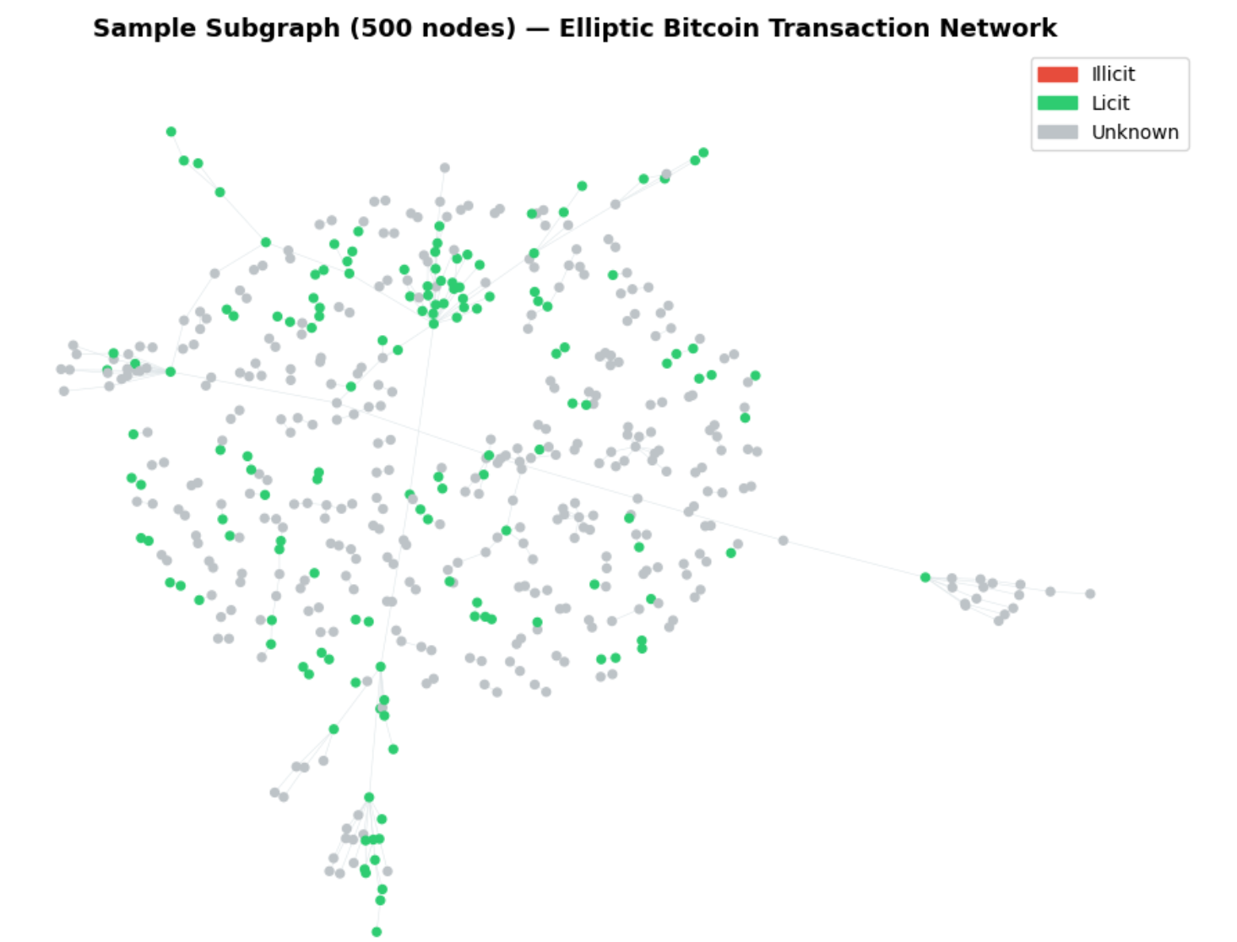

7.1 Evaluation Metrics
Standard accuracy is not used due to the extreme class imbalance (only 10% of labelled nodes are illicit). Instead:
- F1-Score (illicit class): harmonic mean of precision and recall for the minority class
- PR-AUC: Area under the Precision-Recall Curve — robust under class imbalance
- Decision threshold: 0.3 (probability threshold for classifying a node as illicit)

7.2 Metrics:

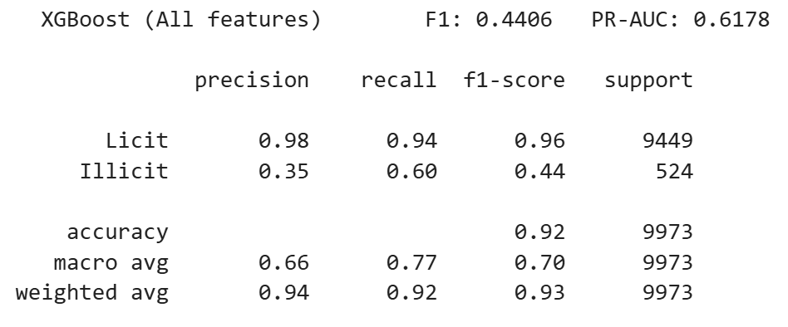
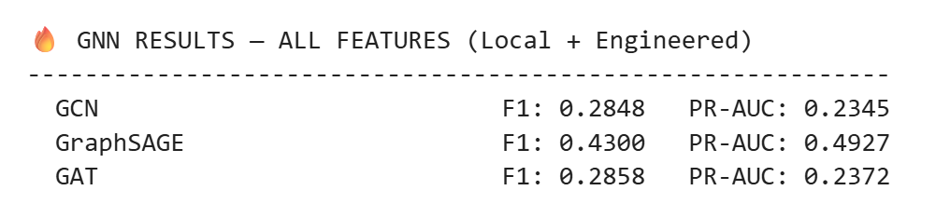
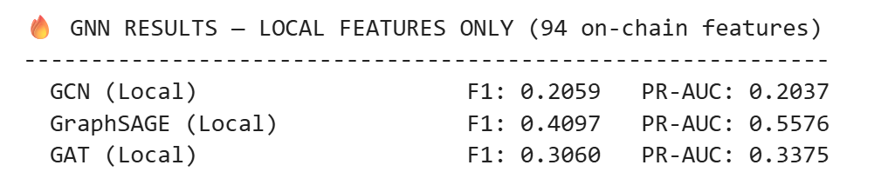
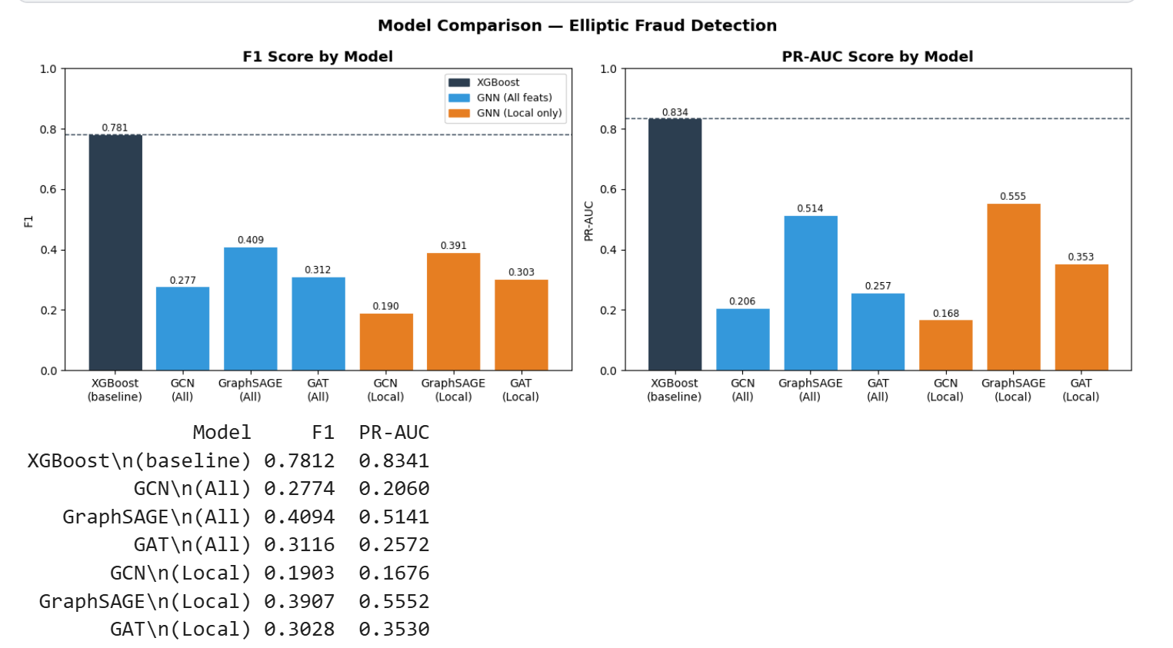

7.3 Key Observations
GraphSAGE is the best GNN: PR-AUC of 0.514 (all features) and 0.555 (local only). Its inductive mean-aggregation is well-suited to this large, sparse, temporally-varying graph.
Local-only features maintain GraphSAGE performance: PR-AUC actually improves from 0.514 to 0.555 when removing aggregated features, confirming the GNN learns neighbourhood structure implicitly through message passing.
XGBoost gap: XGBoost achieves F1=0.781 vs. GraphSAGE's 0.409. This gap is expected given: (a) XGBoost uses 165 features including expert-engineered aggregates; (b) GNNs were trained for only 100 epochs on CPU; (c) no Focal Loss or hyperparameter search for GNNs.

8. Conclusions, Improvements & Limitations

8.1 Conclusions
This project demonstrates that GNNs — particularly GraphSAGE — can effectively detect illicit Bitcoin transactions by learning from the structural topology of the transaction network. The key validation is that GraphSAGE with local-only features achieves competitive PR-AUC (0.555) compared to all-features (0.514), proving that message passing can replace manual multi-hop feature engineering.

8.2 Improvements Over Legacy Approaches
- Eliminates manual feature engineering: GNNs learn neighbourhood statistics automatically
- Multi-hop awareness: GNNs capture 2-hop (and deeper) structural patterns invisible to tabular models
- Inductive inference (GraphSAGE): scores new, unseen transactions at runtime — critical for real-time AML screening
- Structural explainability: GNNExplainer can identify the specific sub-graph driving each prediction

8.3 Limitations & Future Work
- Class imbalance: Focal Loss (Lin et al. 2017) would penalise missed illicit nodes more heavily and likely improve recall significantly
- 77% unlabelled nodes are unused: self-supervised pre-training or pseudo-labelling could leverage this data
- Compute constraints: 100 epochs on CPU limits GNN quality; GPU + 300+ epochs would narrow the gap with XGBoost
- Mini-batch training: NeighborSampler (GraphSAGE) would enable scalable training without full-batch memory constraints
- GNNExplainer not implemented: adding interpretability is essential for regulatory compliance in AML
- Temporal GNNs (e.g., EvolveGCN) could explicitly model the 49 time steps and handle concept drift

